0.1: Building a thinking classroom: laying foundations.
Day 1 of 4 in the unit.
Lesson Objectives: By the end of this unit, students will
- Engage in collaborative problem solving
- Begin internalizing the Thinking Classroom Norms of:
  - Trying something before being taught how.
  - Specializing – trying specific examples
  - Testing and refining ideas
  - Generalizing using notation
  - Challenging their own assumptions.
- Reflect of confirmation bias and what it means to think like a mathematician.
Framing the first 4 classes (for the teacher)
Over the first four days, students will build foundational practices for mathematical thinking that will be reinforced all year. These include
- Getting started: Draw, guess, rephrase. Start messy
- Specialize: Try specific examples; organize your thinking.
- Generalize: Look for patterns, use notation, express ideas broadly
- Test: Look for counter examples
- Conjecture: State general rule or prediction
- Justify: Explain your reasoning, why do you believe it is true
- Convince: Can others follow and believe your reasoning?
- Reflect: what did you try, learn, question or want to revisit.
Todays focus: Specializing, Testing and Generalizing.

Thinking task: Warehouse Discount problem
In a warehouse you obtain a 20% discount but must pay a 15% sales tax. Which order would you prefer them calculated in?
Teacher Moves:
- Visibly, randomly assign students into groups of 3.
- Tell students the prompt verbally.
- Circulate and note strategies.
- If students reach conclusions, ask:
  - Does your result hold for other values?
  - Can you prove your result works for any starting price?

Consolidation:
Note: We will go over the result of the task, however, we are trying to consolidate the thinking process here, not this specific problem.
- How did we start?
- Were any of you convinced you knew the answer before you tested it?
- Why is trying exampled useful?
- Specializing: Trying specific examples.
- Does something working on a specific example mean it will always work?
- How can we be sure a rule is always true
- Generalizing: using variables is usually helpful to show that something is true “for every” as opposed to a specific.
  - P(.8)(1.15) = .92P
  - (1.15)(.8)P = .92P etc.
  - Multiplication is associative, this process is just multiplying three numbers, the order will never matter.
Game break: Guess my rule.
Purpose: Experience Confirmation bias and the need for counter examples.
How to Run it:
- Tell students “I have a rule. I will give you an example of a 3-number sequence that fits my rule. You may test your ideas by giving me your own 3-number sequence, and I will tell you if it fit my rule. You may not ask me what the rule is or ask if you are correct. Your goal is to convince yourself what the rule is.”
- Give the starting sequence 6 – 8 – 10
- Let students propose sequences. Say only “yes that fits” or “No, it doesn’t”
The actual rule: numbers are given in increasing order
Teaching point:
- Most students will only try to confirm what they think the rule is (progressive even numbers, or maybe just even numbers in general)
- Rarely do they try to disprove their own ideas.
- Ask
  - “What did you think the rule is?”
  - If you continued to only ask things that matched your guess of that the rule is would you have ever learned you were wrong
    - A million examples do not prove something correct
  - What sequence would disprove your ideas?
    - A Single counter example can prove an idea wrong.

Consolidation
Introduce two key thinking tools:
- Confirmation bias: the tendency to look only for evidence that supports our belief.
- Counterexample: One specific case that disproves a general statement.
Next:
Start with having students fill in the blanks on sticky notes, then read and go over as a class.

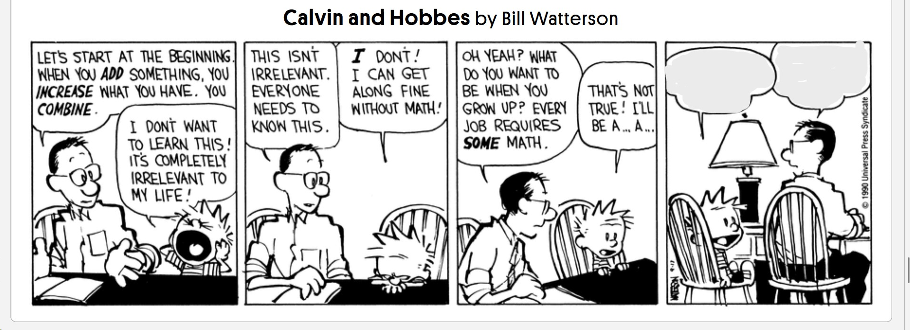
If any time remains, allow students two write questions on a posit and anonymously post them to the board.
Notes for teachers:
- Why this lesson? Traditional first day lessons often focus on procedures or content review. In contrast, this lesson aligns with research on productive struggle, deep thinking and Liljedahl’s Thinking Classroom model. We’re building student norms around curiosity, collaboration, and persistence.
- Structure tip: Don’t front load explanations. Let the students do the heavy lifting. Your role is to prompt, listen, scaffold when needed and only answer/ask keep thinking questions.
Homework: Reflection/ Journal Prompt:
Prompt: “The dividing line between science and pseudoscience is whether advocates of hypothesis deliberately search for evidence that could falsify it and accept the hypothesis only if it survives.” - Karl Popper
Think about the quote above and your instincts today. Did you feel sure about the answer to the warehouse problem before testing it? (For what it is worth, I did and I was wrong. I found it humbling and a great reminder to improve my methods) Did you look for counterexamples in the guess my rule game? Why or why not? What have you learned that you can use going forward in this class? What have you learned that can help you in everyday life?

